Day 4- 113145793 -Dipesh varma

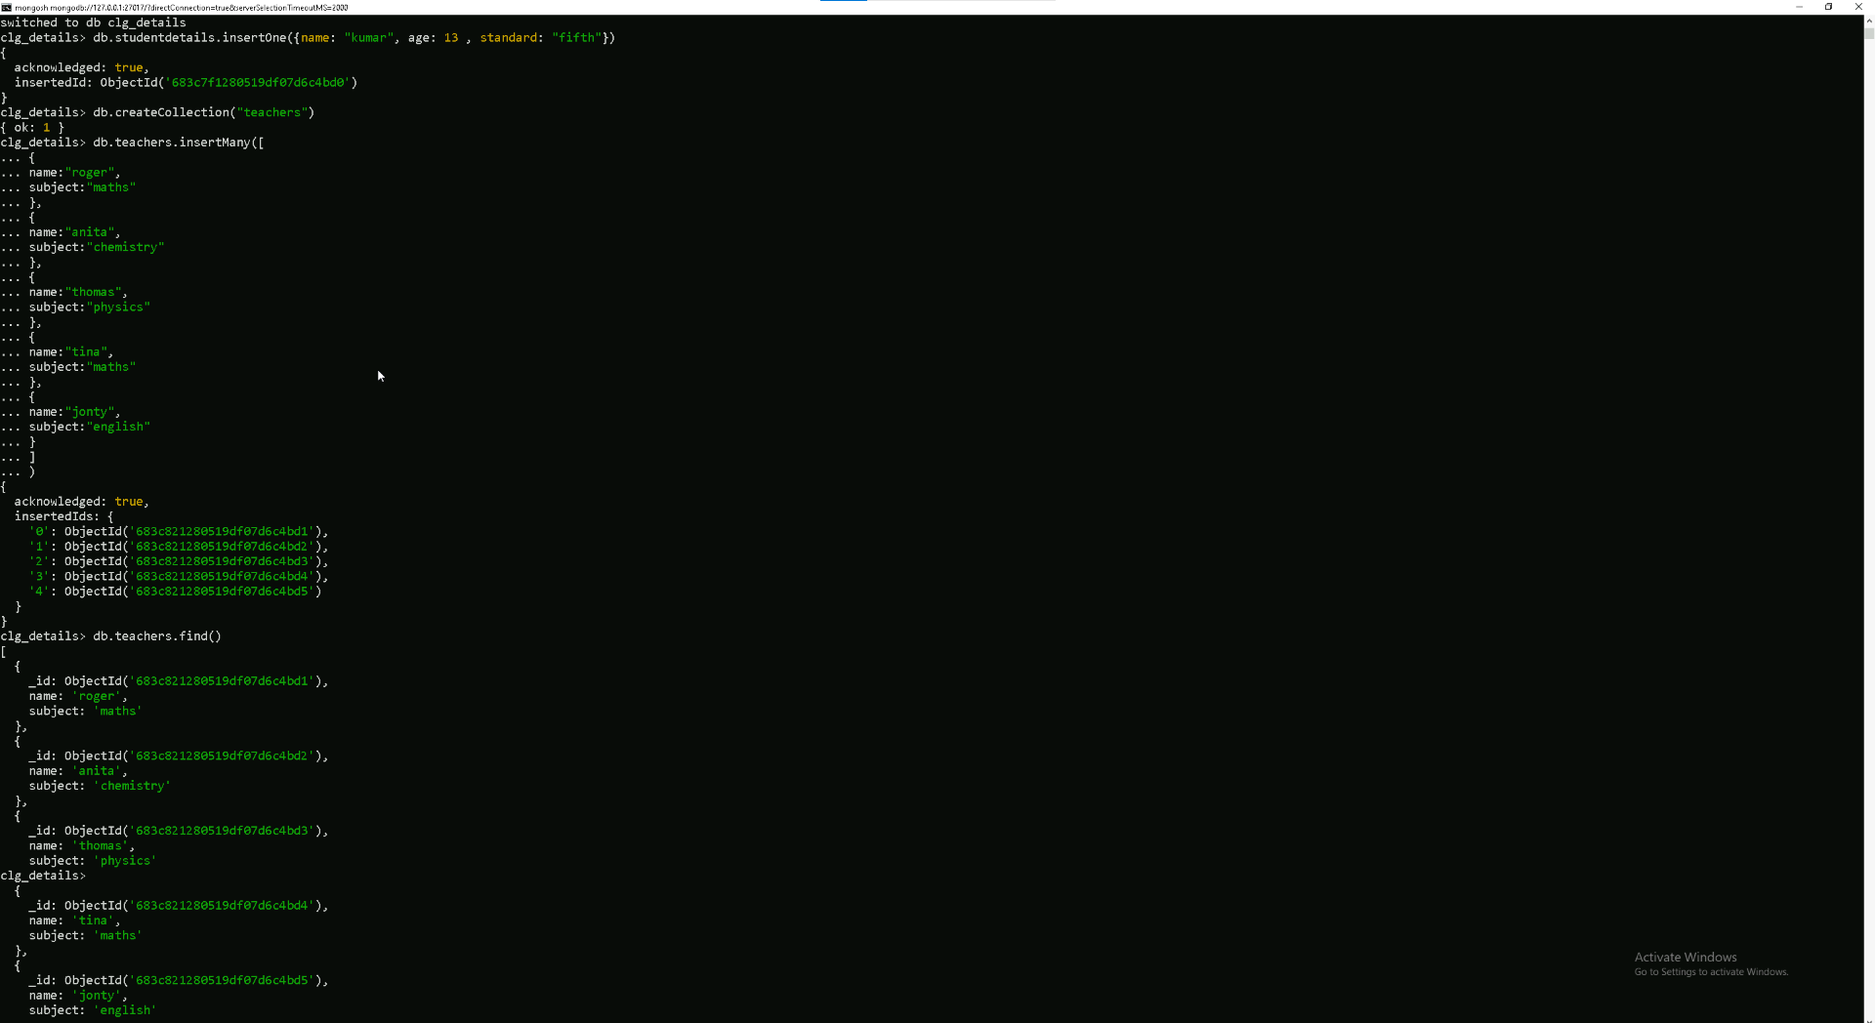
Created a database
Inserted data into database
Created a collection named teachers
Inserted an array of json document using insertmany code.
Used find code to find the data in the teachers collection

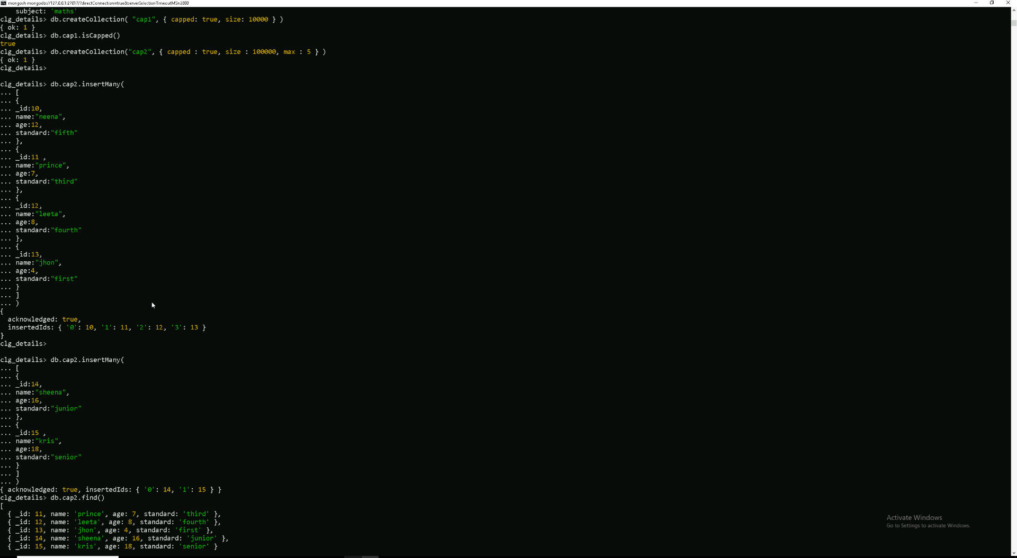
Created capped directories and tested it by inserting data into it.
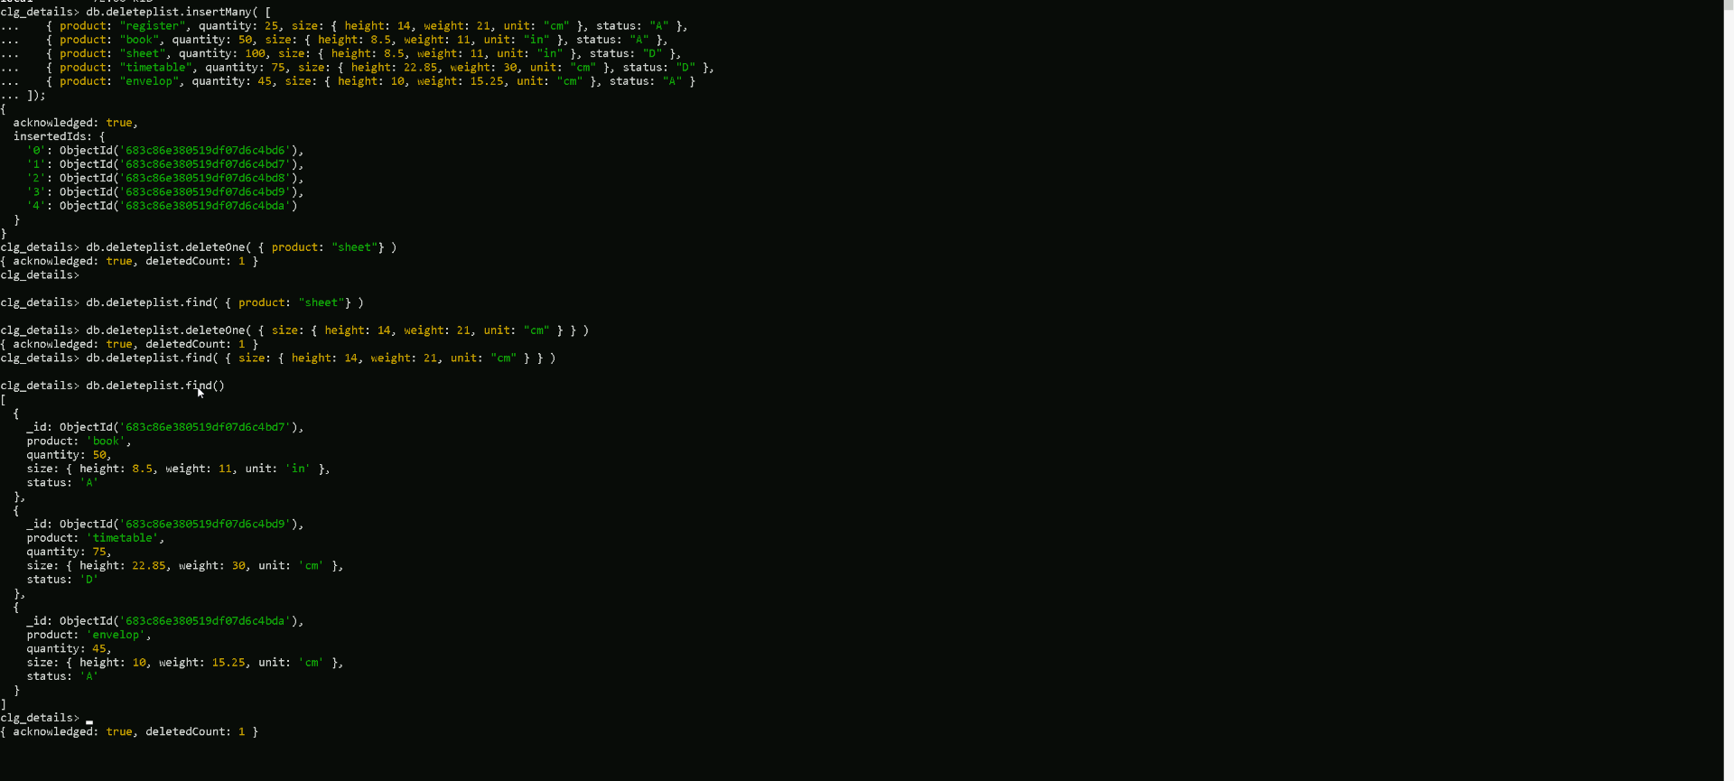
Created a db to test different types of delete options and tried.
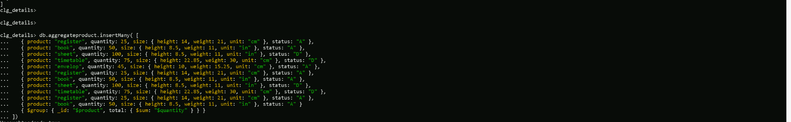
Added data to test the aggregate function.
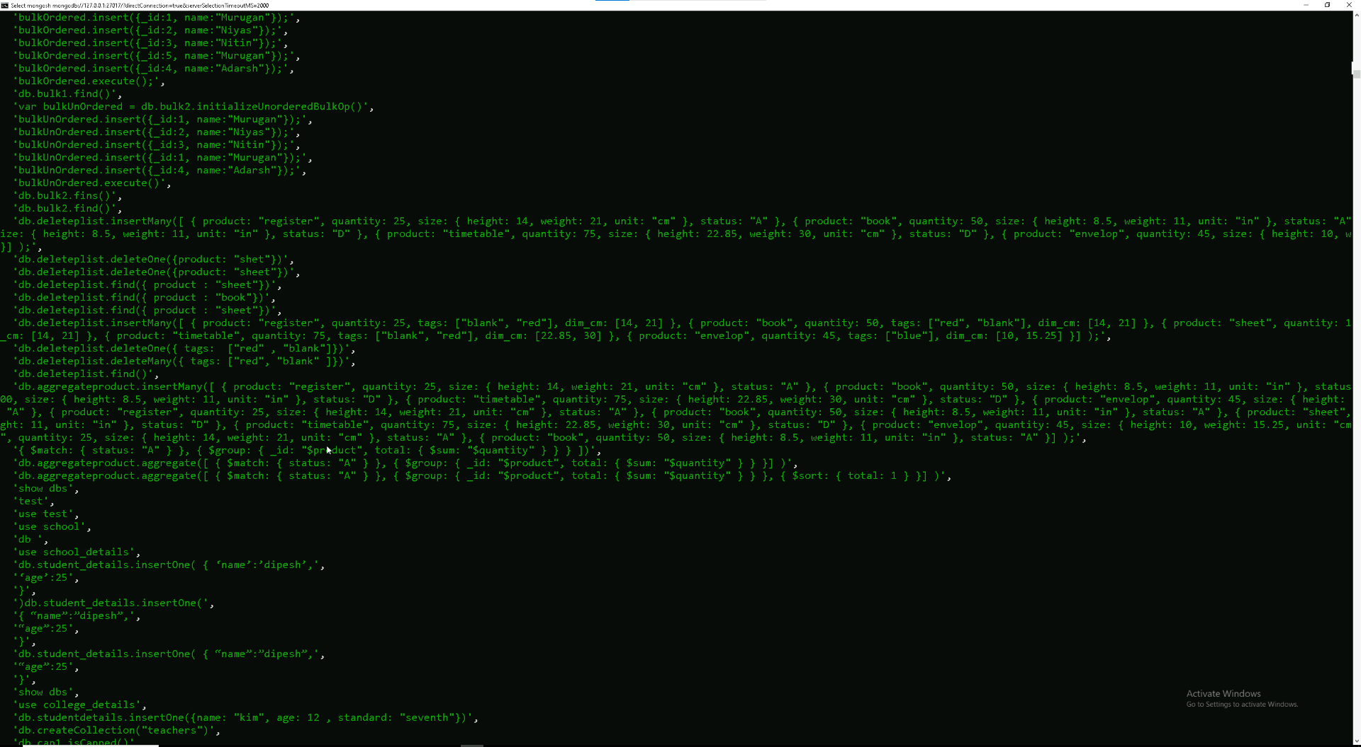
Pulled up the history of commands by history().

